CISB5123 Text Analytics
Lab 2 – Regular Expressions

Introduction:
Regular Expressions are texts patterns that are applied to search, match, and manipulate text information. The re (regular expression) module is also built-in in Python and enables users to do such operations as matching patterns, extracting certain information, splitting text, and text replacement.
Various regular expression functions such as match, search, findall, split and sub are used to solve real world text processing problems in this lab. The lab shows the use of metacharacters and special symbols to construct search patterns and how regular expressions can be useful in processing structured and unstructured textual data.
This lab aims at learning how regular expressions operate and how they can be used to extract meaningful information in given text samples.
Code:

import re

# Exercise 1: Extract all digits

text1 = "Order number: 24567, Tracking ID: 8934A12, Quantity: 30"

pattern1 = r'\d+'
matches1 = re.findall(pattern1, text1)

print("Exercise 1 Output:")
print("Digits found:", matches1)
print()

# Exercise 2: Extract non-alphanumeric characters

text2 = "Welcome! How's your day going? Call me @ 3pm."

pattern2 = r'[^a-zA-Z0-9]'
matches2 = re.findall(pattern2, text2)

print("Exercise 2 Output:")
print("Non-alphanumeric characters:", matches2)
print()

# Exercise 3: Split at commas and periods

text3 = "Data Science, AI, and Machine Learning. These fields are growing fast."

pattern3 = r'[,.]'
split_text = re.split(pattern3, text3)

print("Exercise 3 Output:")
print("Split text:", split_text)
print()

# Exercise 4: Replace email addresses

text4 = "Contact us at support@example.com or info@company.org"

pattern4 = r'\w+@\w+\.\w+'
new_text = re.sub(pattern4, "[HIDDEN]", text4)

print("Exercise 4 Output:")
print("Anonymized text:", new_text)
print()

# Exercise 5: Extract domain types

text5 = "Emails: user@gmail.com, admin@university.edu, info@company.org"

pattern5 = r'@\w+\.(\w+)'
matches5 = re.findall(pattern5, text5)

print("Exercise 5 Output:")
print("Domain types:", matches5)

Exercise 1 – Extract All Digits:
import re

# Exercise 1: Extract all digits

text1 = "Order number: 24567, Tracking ID: 8934A12, Quantity: 30"

pattern1 = r'\d+'
matches1 = re.findall(pattern1, text1)

print("Exercise 1 Output:")
print("Digits found:", matches1)
print()

Output:
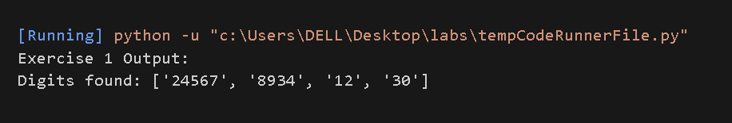

Explanation:

In the exercise, numeric values will be extracted using the regular expression pattern of \d+ to extract the numbers in the text.

- \d matches any digit from 0 to 9.

- refers to a single or multiple occurrences.

- Thus, the expression d+ does not match a single digit but a whole number.

This is done by use of re.findall() because all the matching values are returned as a list. In this scenario, it removes any form of numbers in the string provided like the order number, tracking ID digits and quantity.

This illustrates that through the application of regular expressions it is possible to extract numerical data in a text.

Exercise 2 – Extract Non-Alphanumeric Characters

Code:

# Exercise 2: Extract non-alphanumeric characters

text2 = "Welcome! How's your day going? Call me @ 3pm."

pattern2 = r'[^a-zA-Z0-9]'
matches2 = re.findall(pattern2, text2)

print("Exercise 2 Output:")
print("Non-alphanumeric characters:", matches2)
print()

Output:
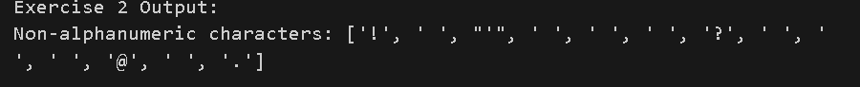

Explanation:

Here, the regular expression [a-zA-Z0-9] is applied to get the characters which are not letters and numbers.
- A character set is defined by square brackets [ ] being used.
- a-zA-Z0-9 indicates all the lower letters and capital letters and numbers.
- The careting in the brackets denotes not.
As such, the pattern corresponds to all but letters and numbers.
The re.findall () function gives all these characters with spaces, punctuation marks, and symbols.
This demonstrates that regular expressions may be used to sieve out undesired characters in text.

Exercise 3 – Split at Commas and Periods:

Code:
text3 = "Data Science, AI, and Machine Learning. These fields are growing fast."

pattern3 = r'[,.]'
split_text = re.split(pattern3, text3)

print("Exercise 3 Output:")
print("Split text:", split_text)
print()

Output:
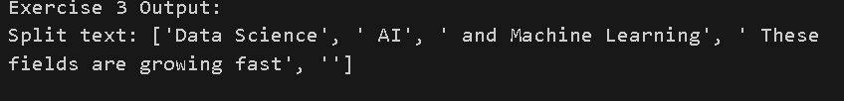

Explanation:

The text is divided into the pattern [,] in this exercise.

- Square brackets enable correspondingness of two or more characters.
- , represents comma.
- . represents period.
- The pattern of the strings is divided by the commas or periods.

Re.split() function splits the string along with a specified pattern and makes a list of substrings.

This is an illustration of the application of regular expressions to divide text into smaller elements with several delimiters.

Exercise 4 – Replace Email Addresses:

Code:
# Exercise 4: Replace email addresses

text4 = "Contact us at support@example.com or info@company.org"

pattern4 = r'\w+@\w+\.\w+'
new_text = re.sub(pattern4, "[HIDDEN]", text4)

print("Exercise 4 Output:")
print("Anonymized text:", new_text)
print()

Output:
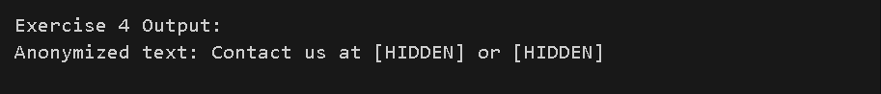
Explanation:

The email addresses are matched against the pattern w + at w +.w + in this exercise.

- w+ It is a match of one or more word marks (letters, numbers, underscore).
- @ matches the at symbol.
- \. matches a literal dot. It is evaded as dot is a special metacharacter.
- The last w+ refers to the type of the domain (e.g. com or org).

The re.sub() command subsitutes all the email address that matches with the word [HIDDEN].

This demonstrates how regular expressions may be utilized in anonymizing sensitive information in text.

Exercise 5 – Extract Domain Types:

Code:
# Exercise 5: Extract domain types

text5 = "Emails: user@gmail.com, admin@university.edu, info@company.org"

pattern5 = r'@\w+\.(\w+)'
matches5 = re.findall(pattern5, text5)

print("Exercise 5 Output:")
print("Domain types:", matches5)
print()

Output:
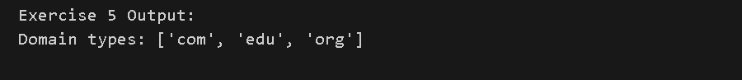
Explanation:

The pattern applied in this exercise at the expense of email addresses is the @w+.w+ to retrieve only the domain type.

- w+ is a domain name following the symbol of at.
- . is equivalent to the dot preceding the type of the domain.
- (\w+) is a capturing group. It only removes the type of domain as com, edu or org.

The reason why the parentheses are necessary is that re.findall() only gives the portion within the capturing group.

This shows that grouping a regular expression enables one to extract certain components of a regular expression rather than the entire match.

